Assignment 1: Class Structuring & Object Interaction

Problem Statement
Create a Book class with attributes title, author, ISBN, and status, along with a method to display its details.

Source Code

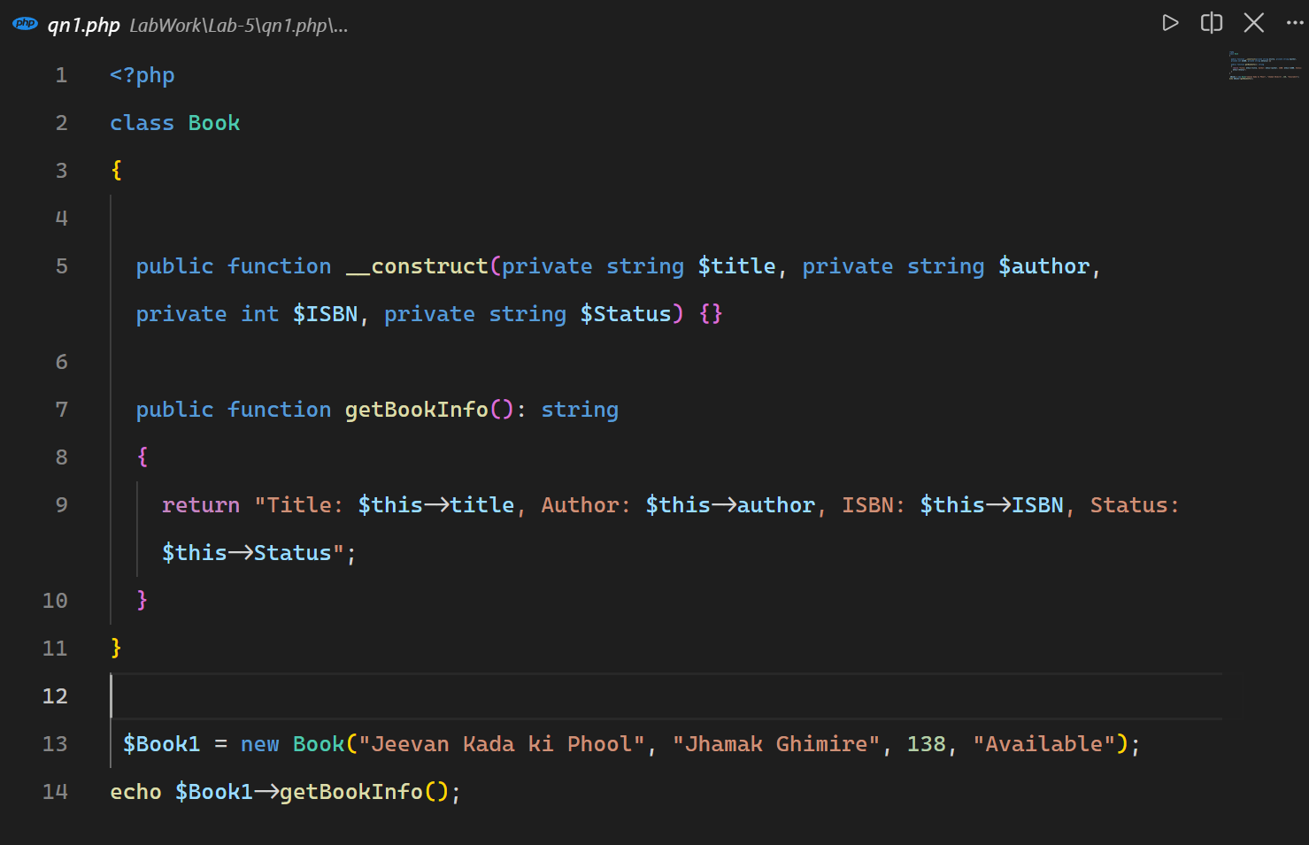

Output
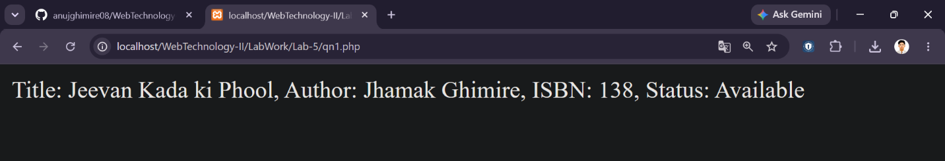

Assignment 2: Constructor & Destructor

Problem Statement
Create a Pet class with a constructor to initialize its attributes and a destructor that displays a confirmation message when the object is destroyed.

Source Code
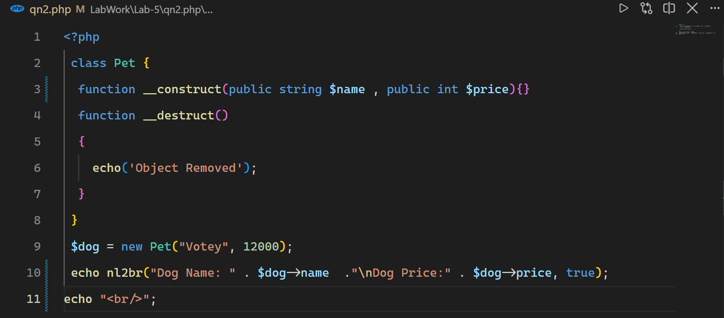

Output
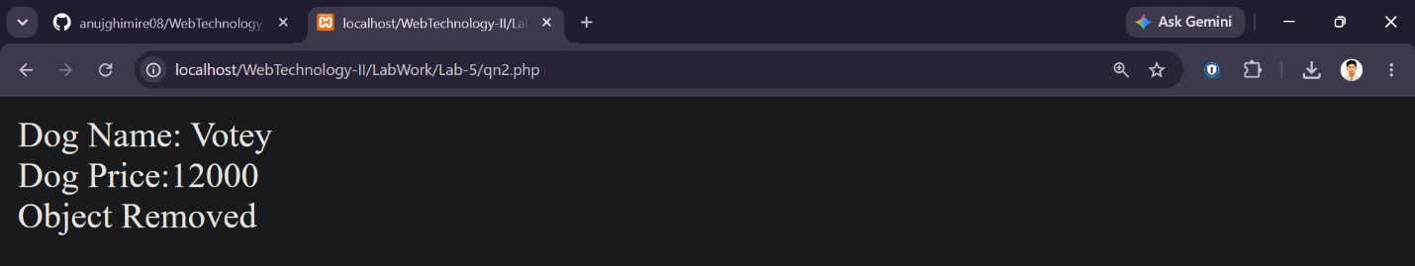

Assignment 3: Encapsulation & Inheritance

Problem Statement
Create a Person class with protected name and email attributes and public getters and setters. Extend it into Student and Staff classes with their respective additional attributes.

Source Code
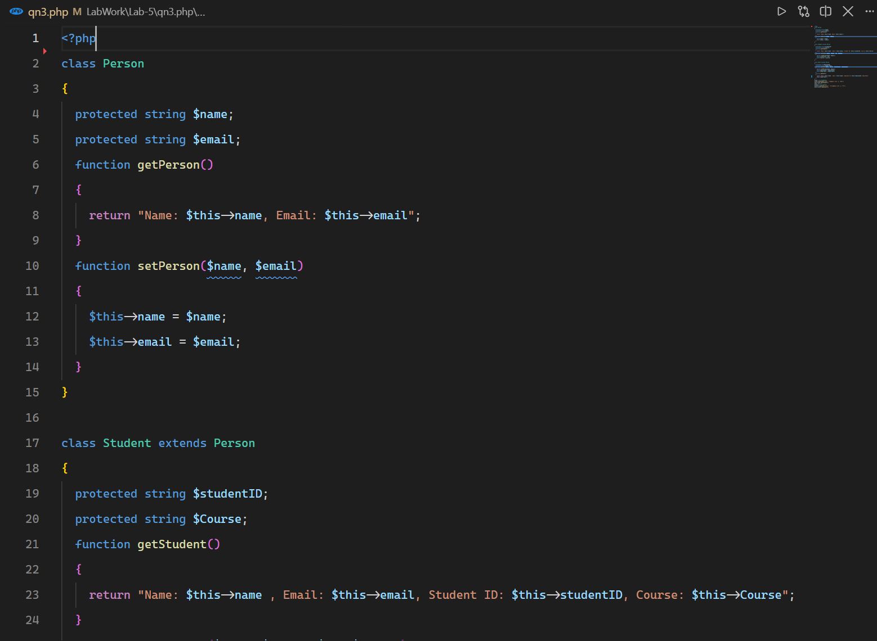

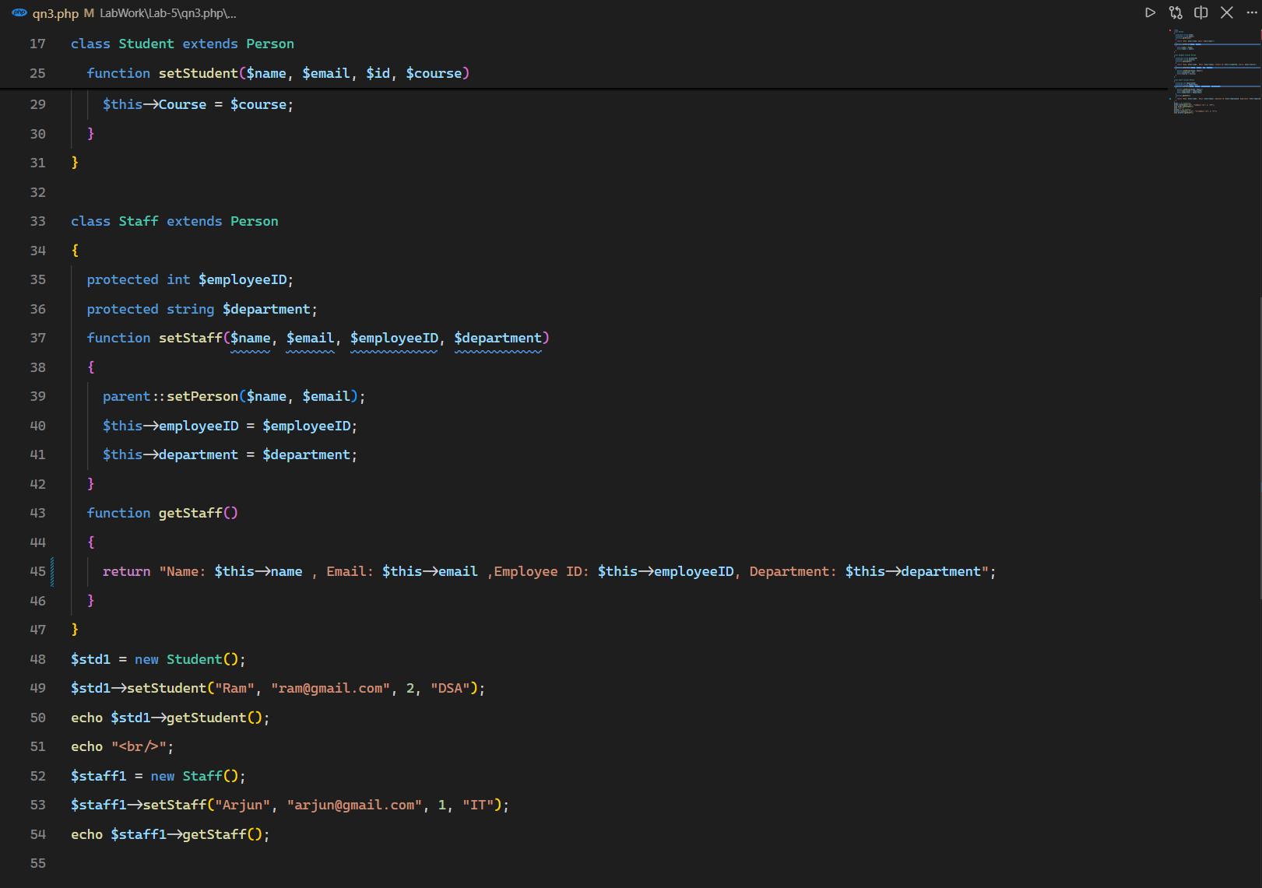

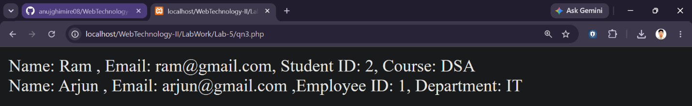
Output

Assignment 4: Interfaces & Abstract Classes

Problem Statement
Create an IVehicle interface containing start(), stop(), and fuelStatus() methods. Create an abstract Vehicle class that implements the interface and derive concrete Car and Truck classes from it.

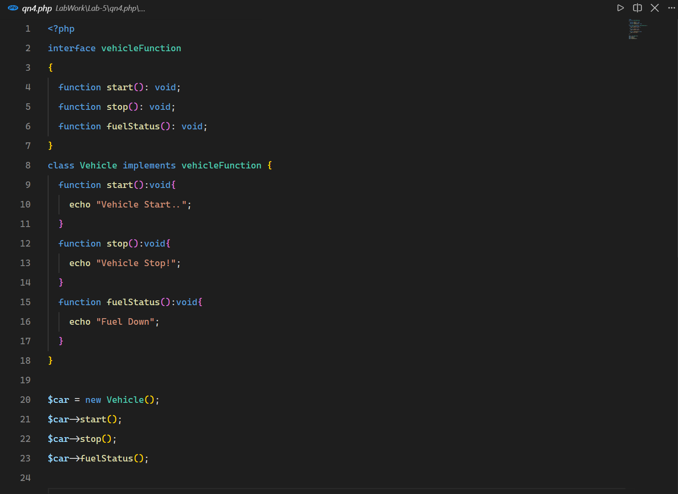
Source Code

Output
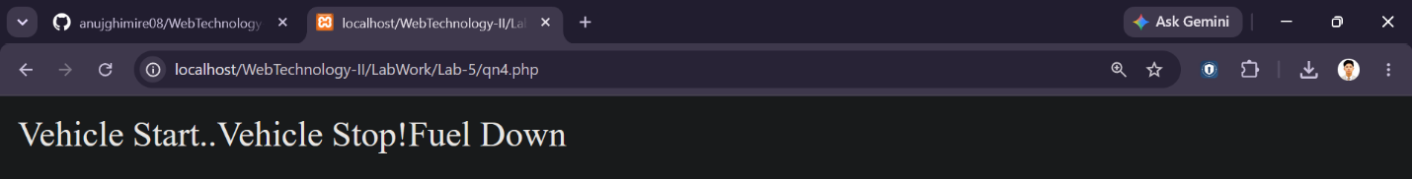

Assignment 5: Exception Handling

Problem Statement
Create a Calculator class with a divide() method. Use try-catch and throw to detect division by zero and display a user-friendly exception message.

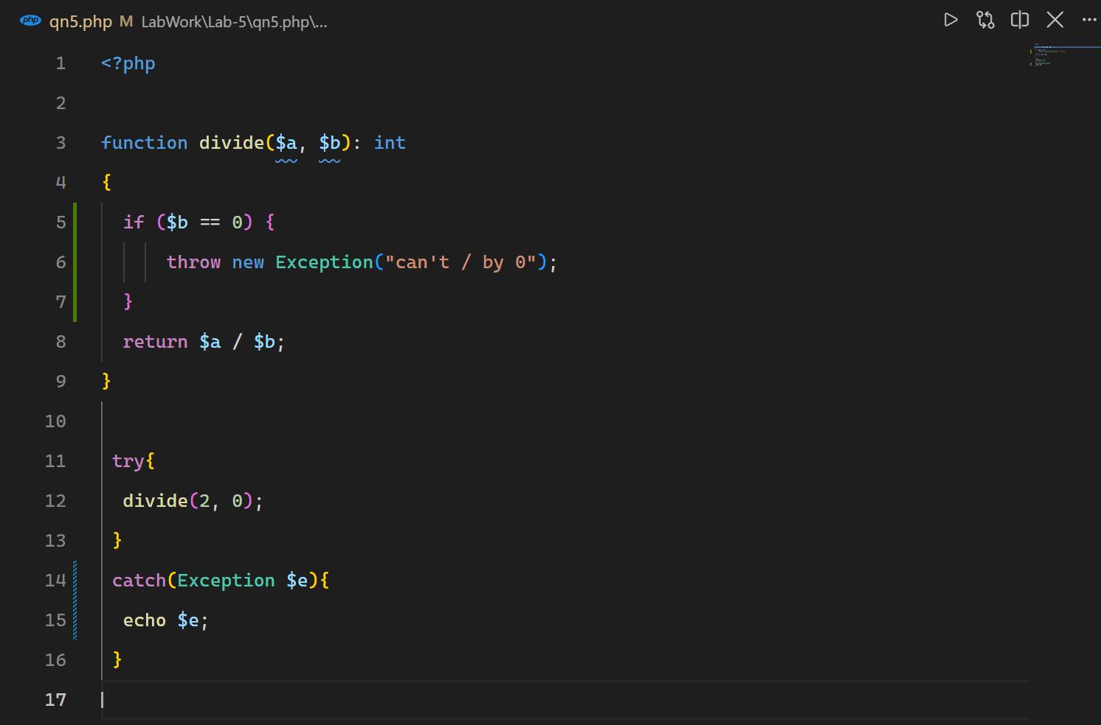
Source Code

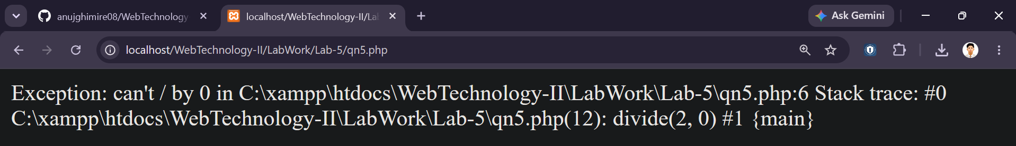
Output

